Chapter 4
IMPLEMENTATION

4.1 Pseudo Code
Implementation of the system using annotations and informative text conveyed in clear and straightforward English language.

4.1.1 Data Collection
Below is the pseudocode for the Python script I used for data collection, this pseudocode captures the main structure and logic of the original Python script while abstracting away the specific syntax details.
START
Import necessary libraries (cv2, HandDetector, numpy, os, traceback)
INITIALIZE video capture from default camera
INITIALIZE hand detectors (hd, hd2) with maxHands=1
SET initial variables (count, c_dir, offset, step, flag, suv)
CREATE and save a white image (400x400)
WHILE True:
READ frame from video capture
FLIP frame horizontally
DETECT hands in frame using hd
LOAD white image
IF hand detected:
EXTRACT hand bounding box coordinates (x, y, w, h)
CROP hand image from frame
DETECT hand landmarks using hd2 in cropped image
IF landmarks detected:
CALCULATE offsets for centering hand
DRAW hand skeleton on white image using landmarks
SAVE final skeleton image as skeleton1
DISPLAY skeleton image
OVERLAY text with directory and image count on frame
DISPLAY frame
IF 'Esc' key pressed:
BREAK loop
IF 'n' key pressed:
INCREMENT c_dir to next character
RESET flag to False
UPDATE count with images in new directory
IF 'a' key pressed:
TOGGLE flag
IF flag is True:
IF suv equals 180:
SET flag to False
IF step is multiple of 3:
SAVE skeleton1 image to current directory
INCREMENT count and suv
INCREMENT step
HANDLE any exceptions and print traceback
RELEASE video capture and destroy windows
END
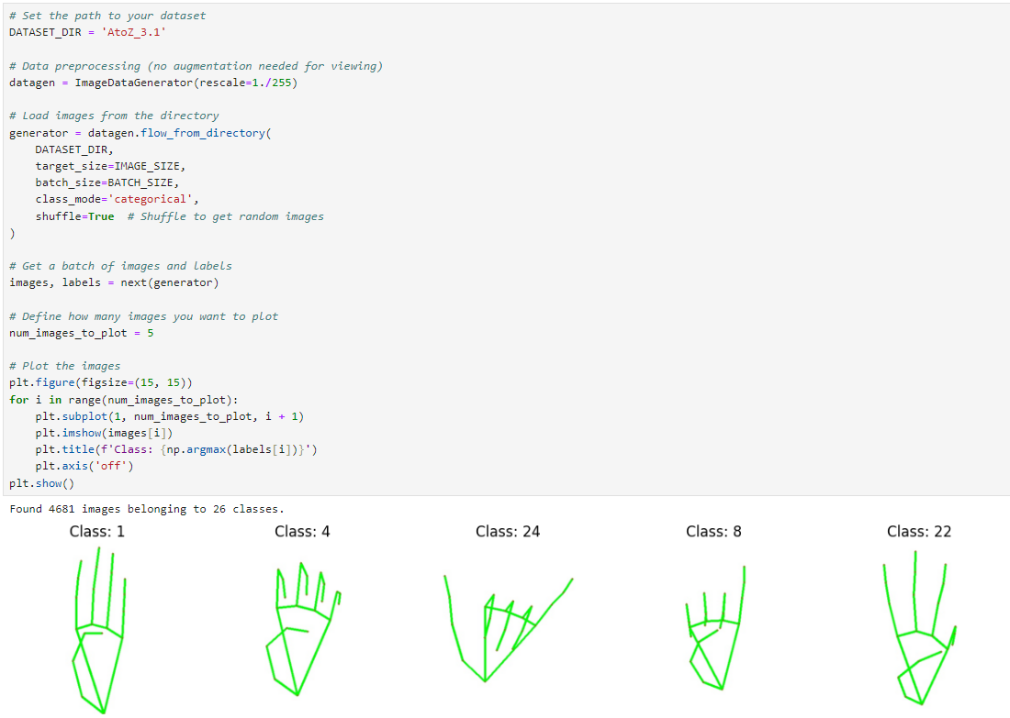
Figure 4.1: Mediapipe Hand Landmark Saved in Dataset

4.1.2 Model Training
Below is the pseudocode for the Python script I used for training the TensorFlow model.
START
Import necessary libraries (matplotlib, numpy, ImageDataGenerator)
DEFINE constants (IMAGE_SIZE, BATCH_SIZE)
SET dataset directory path (DATASET_DIR)
INITIALIZE ImageDataGenerator with rescale option
LOAD images from directory using flow_from_directory
SET target size, batch size, class mode, shuffle
RETRIEVE a batch of images and labels using next(generator)
SET number of images to plot (num_images_to_plot)
FOR each image in num_images_to_plot:
DISPLAY image using plt.imshow()
DISPLAY corresponding class label using np.argmax(labels[i])
DISABLE axis display for cleaner look
RENDER images on screen using plt.show()
END
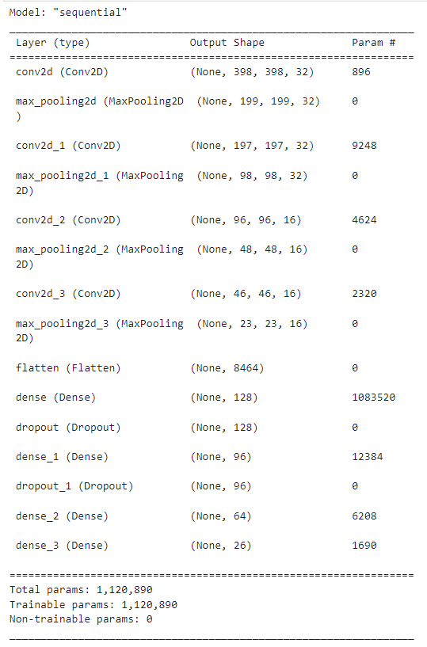
Figure 4.2: Model Summary

4.1.3 Prediction
Below is the pseudocode for the Python script I used for hand sign prediction.
START
IMPORT necessary libraries
LOAD pre-trained ASL classification model
INITIALIZE video capture and hand detector
DEFINE class labels and preprocessing parameters
WHILE capturing frames:
READ and process frame
DETECT hand and extract landmarks
IF hand detected:
PREPROCESS landmarks for model input
PERFORM prediction using the model
DISPLAY prediction on frame
DISPLAY the frame
HANDLE user input for exit and controls
RELEASE resources and exit
END
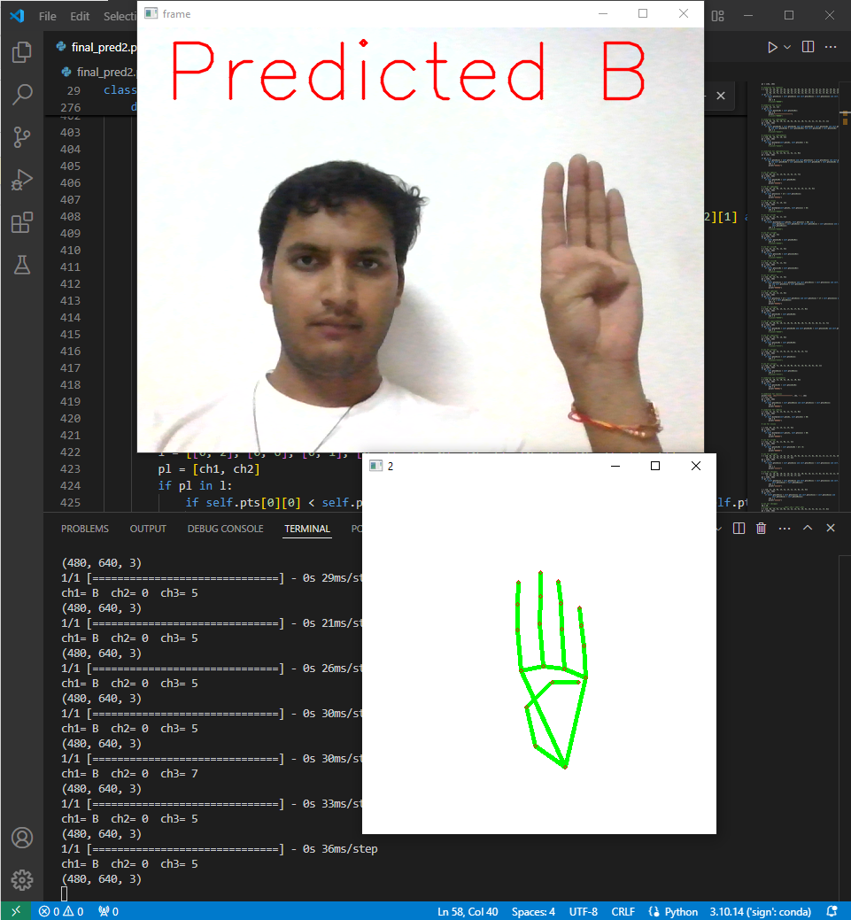
Figure 4.3: Prediction of Alphabet

4.2 Testing
Testing can be stated as the process of verifying and validating whether a software or application is bug-free, meets the technical requirements as guided by its design and development, and meets the user requirements effectively and efficiently by handling all the exceptional and boundary cases. The process of software testing aims not only at finding faults in the existing software but also at finding measures to improve the software in terms of efficiency, accuracy, and usability. It mainly aims at measuring the specification, functionality, and performance of a software program or application. Figure 4.4 cover all the types of testing in involved in Software testing.
Software level testing can be majorly classified into 4 levels:
  - Unit Testing: A level of the software testing process where individual units/components of a software/system are tested. The purpose is to validate that each unit of the software performs as designed.
  - Integration Testing: A level of the software testing process where individual units are combined and tested as a group. The purpose of this level of testing is to expose faults in the interaction between integrated units.
  - System Testing: A level of the software testing process where a complete, integrated system/software is tested. The purpose of this test is to evaluate the system’s compliance with the specified requirements.
  - Acceptance Testing: A level of the software testing process where a system is tested for acceptability. The purpose of this test is to evaluate the system’s compliance with the business requirements and assess whether it is acceptable for delivery.
INCLUDEPICTURE "https://media.geeksforgeeks.org/wp-content/uploads/20190530151220/331.jpg" \* MERGEFORMATINET INCLUDEPICTURE "https://media.geeksforgeeks.org/wp-content/uploads/20190530151220/331.jpg" \* MERGEFORMATINET INCLUDEPICTURE "https://media.geeksforgeeks.org/wp-content/uploads/20190530151220/331.jpg" \* MERGEFORMATINET INCLUDEPICTURE "https://media.geeksforgeeks.org/wp-content/uploads/20190530151220/331.jpg" \* MERGEFORMATINET INCLUDEPICTURE "https://media.geeksforgeeks.org/wp-content/uploads/20190530151220/331.jpg" \* MERGEFORMATINET INCLUDEPICTURE "https://media.geeksforgeeks.org/wp-content/uploads/20190530151220/331.jpg" \* MERGEFORMATINET INCLUDEPICTURE "https://media.geeksforgeeks.org/wp-content/uploads/20190530151220/331.jpg" \* MERGEFORMATINET INCLUDEPICTURE "https://media.geeksforgeeks.org/wp-content/uploads/20190530151220/331.jpg" \* MERGEFORMATINET INCLUDEPICTURE "https://media.geeksforgeeks.org/wp-content/uploads/20190530151220/331.jpg" \* MERGEFORMATINET INCLUDEPICTURE "https://media.geeksforgeeks.org/wp-content/uploads/20190530151220/331.jpg" \* MERGEFORMATINET INCLUDEPICTURE "https://media.geeksforgeeks.org/wp-content/uploads/20190530151220/331.jpg" \* MERGEFORMATINET INCLUDEPICTURE "https://media.geeksforgeeks.org/wp-content/uploads/20190530151220/331.jpg" \* MERGEFORMATINET INCLUDEPICTURE "https://media.geeksforgeeks.org/wp-content/uploads/20190530151220/331.jpg" \* MERGEFORMATINET INCLUDEPICTURE "https://media.geeksforgeeks.org/wp-content/uploads/20190530151220/331.jpg" \* MERGEFORMATINET INCLUDEPICTURE "https://media.geeksforgeeks.org/wp-content/uploads/20190530151220/331.jpg" \* MERGEFORMATINET INCLUDEPICTURE "https://media.geeksforgeeks.org/wp-content/uploads/20190530151220/331.jpg" \* MERGEFORMATINET INCLUDEPICTURE "https://media.geeksforgeeks.org/wp-content/uploads/20190530151220/331.jpg" \* MERGEFORMATINET INCLUDEPICTURE "https://media.geeksforgeeks.org/wp-content/uploads/20190530151220/331.jpg" \* MERGEFORMATINET INCLUDEPICTURE "https://media.geeksforgeeks.org/wp-content/uploads/20190530151220/331.jpg" \* MERGEFORMATINET 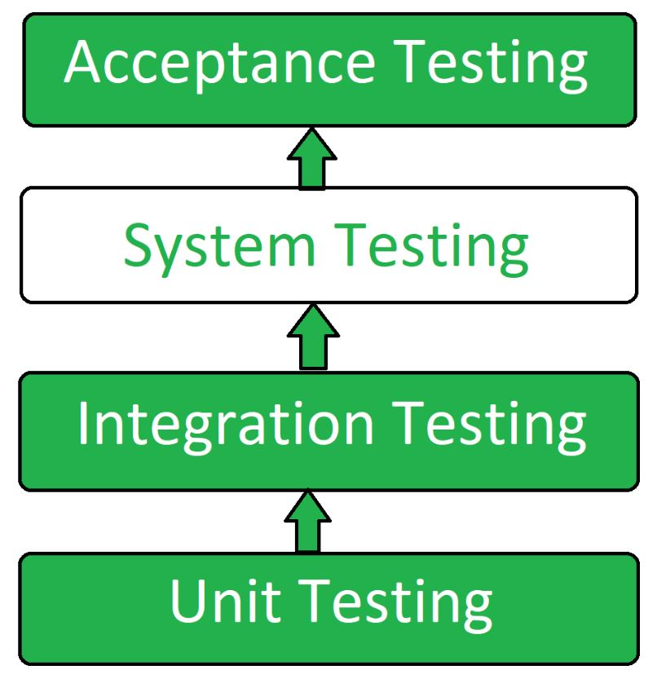
Figure 4.4: Testing Steps

4.2.1 Testing Process
The testing process for the “HandTalk: Real-Time Hand Sign Recognition” system was divided into several key modules, each of which required the creation of specific test cases to ensure the system's functionalities performed as expected. Figure 4.4 illustrates the flowchart of the entire testing process.
The main modules tested include:
- Home Module: This is the primary module where the user interacts with the application. In this module, the live camera feed captures hand gestures, and the system displays recognized ASL signs. Test cases for this module included checking the functionality of the camera feed, real-time hand sign recognition, and the display of the current alphabet and word suggestions.
- Hand Sign Recognition Module: This module focuses on recognizing ASL signs from the live camera feed. Test cases here involved verifying the accuracy of the recognition system for each hand sign (A-Z), as well as the additional "Next" and "Backspace" signs. The tester ensured that the system responded correctly in various lighting conditions and with different hand orientations.
- Clear and Speak Buttons: This module handles the user interactions for clearing input and using text-to-speech functionality. Test cases included ensuring that the "Clear" button successfully resets the input without crashing the application, and that the "Speak" button accurately converts the recognized word into speech.
Testing Workflow:
- Unit Testing: The initial phase involved unit testing by the developers. I independently tested the various modules, focusing on individual functionalities like the accuracy of hand recognition, UI responsiveness, and integration of Mediapipe and TensorFlow. This ensured that each module operated correctly on its own.
- Integration Testing: Once individual modules passed unit testing, they were integrated and deployed on a production server, which simulated the actual application environment. This allowed us to test how different modules interacted with each other. We checked the seamless flow from the live camera feed to hand sign recognition and output display, as well as ensuring that the backend and frontend communicated properly.
- Quality Assurance Testing: After integration, the project was handed over to the Tester. They created and executed essential test cases for all modules, focusing on both functionality and usability. They assessed the accuracy of hand sign recognition, responsiveness of buttons, word construction, and overall user experience. We also tested the system under various conditions, such as different lighting environments, hand angles, and frame rates.
- Bug Fixing and Iteration: If any test cases failed, We provided detailed feedback on the issues encountered. The development team updated the code to resolve the bugs, after which the updated modules were re-tested. This iterative process was repeated for each module until all test cases passed successfully.
Once all test cases passed, the system was deemed ready for deployment, ensuring that the HandTalk application operated smoothly and accurately in real-world conditions.
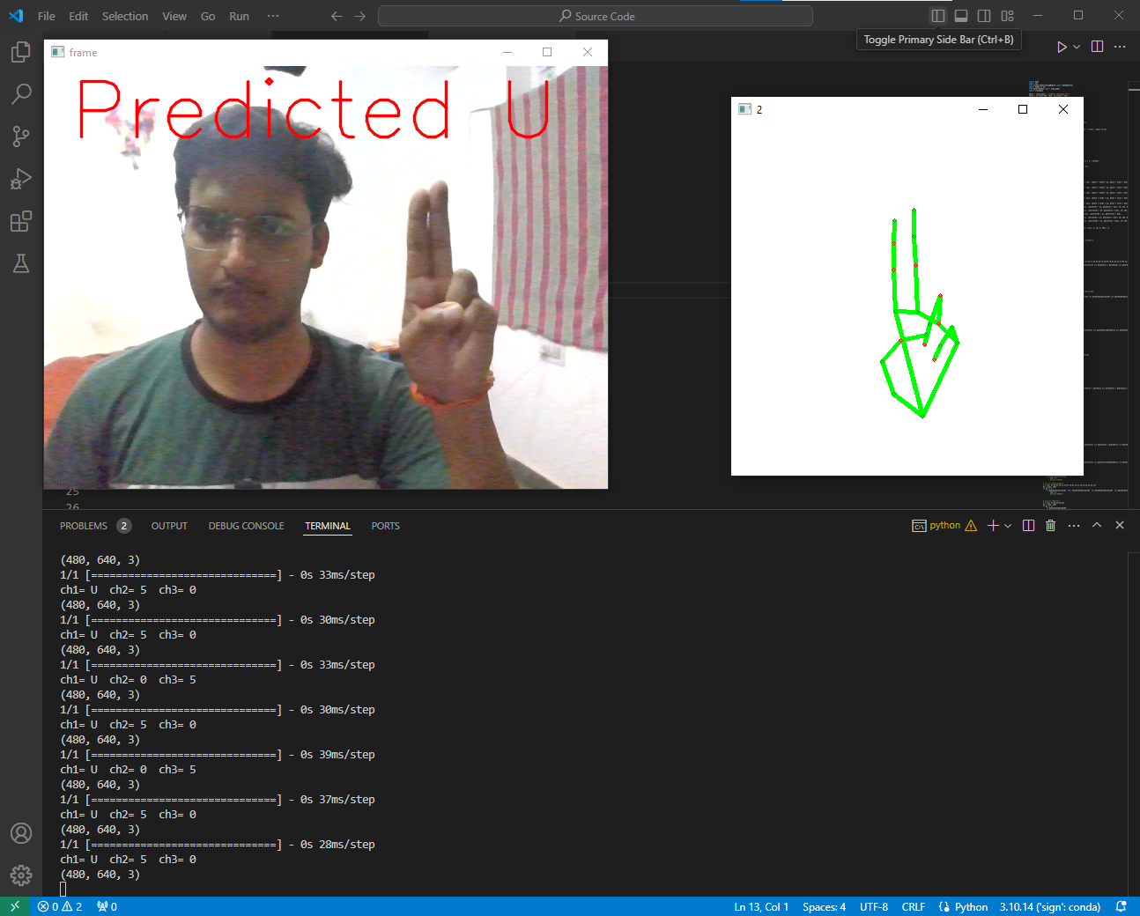
Figure 4.5: Testing Without GUI

